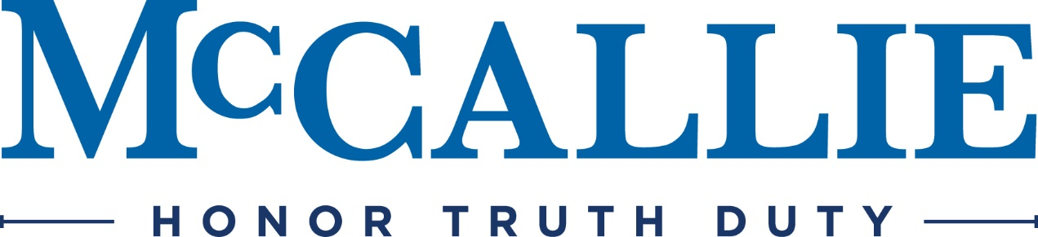

Aug 5, 2021

Invitation to Enroll in the Bus Transportation Program
For the 2021-2022 Academic Year

Dear Parent(s),

You are invited to enroll in our bus service for the academic year beginning August 17, 2021. Bus routes will be provided on a round trip basis to the following locations: Cleveland, Ooltewah, Dalton We reserve the right to cancel a bus route if there is not enough interest for the route to be viable and you will be notified if we do not have enough riders to justify your particular route.

There are limited seats available so reservations will be processed based on our receipt of your $100.00 deposit and a completed application form. The cost will be billed on your son’s student billing account at the beginning of each semester. Please return your registration no later than August 14, 2021.

As you may know, the fees we charge for the bus service only nominally cover depreciation costs. We usually find it necessary on an annual basis to raise the charges for our bus service due to increased operating costs (primarily gas, repairs and salaries). The rates per semester are reflected on the 2021-22 Bus Transportation Schedule, enclosed.

Occasional rides will be allowed if there is space available. The charge will be $10 per ride and will be billed to your son’s student billing account. Please submit a registration form even if you are only interested in occasional rides so that you will be on our notification list for schedule changes.

If you have any questions on this program, please call April de la Torre at 423-493-5651.

Sincerely,

April de la Torre
Physical Plant

